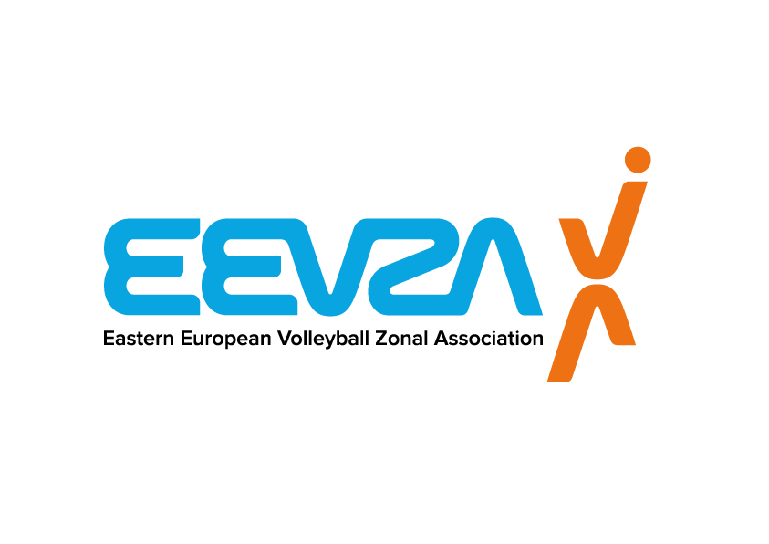 | 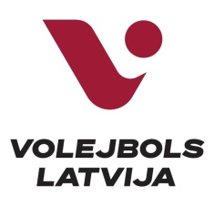 | 
EEVZA U18 and U16 Beach Volleyball Championship 2022
PRACTICAL INFO
EVENT’S TITLE | EEVZA U18/U16 Beach volleyball Championship 2022
VENUE | “O-sands” Beach volleyball courts, Aleksandra Laimes str. 2, Riga, Latvia
DATE | 22.-23.08.2022
LOCAL ORGANISER | Volleyball federation of Latvia  Web: www.volejbols.lv  Phone: +371 67869774, e-mail: lvf@volejbols.lv
EEVZA | Eastern European Volleyball Zonal Association  http://www.eevza.eu/  Email: info@ltf.lt  Beach volleyball coordinator, Ms. Alisa Cesnuleviciute  E-mail: secretarygeneral@eevza.eu  Secretary General, Mrs. Inara Brokane
NATIONAL FEDERATION | Volleyball federation of Latvia  Web: www.volejbols.lv  Phone: +371 67869774, e-mail: lvf@volejbols.lv
REGISTRATION | To be admitted to participate in the competition, the National Federation must complete a Registration Form, duly signed and stamped by concerned National Federation. All teams from EEVZA countries who are interested to participate, should send an official request (also WC requests) from their National Federation to following e-mails:  To: info@ltf.lt;  Cc: secretarygeneral@eevza.eu  Deadline: 15.08.2022
ORGANIZING COMMITTEE | Organizers’ Area  Tournament Director Edgars Zaizenijs +371 22034343 edgars@volejbols.lv  NF Delegate: Toms Smedins +371 26101226 toms@volejbols.lv  Technical and Administrative Area  EEVZA Technical Supervisor tbd  Technical Director tbd  Court Manager tbd  Referee Manager Aleksandrs Polevs +371 22426957 aleksandrs.polevs@inbox.lv  BVIS Manager Liene Libere +371 26750898 libereliene@gmail.com
REFEREES | NF Referee Manager:  Aleksandrs Polevs, +371 22426957, aleksandrs.polevs@inbox.lv  Local Referees: tbd
GENDER | Men/Women
RIGHT OF PARTICIPATION | - Players wishing to participate shall be aged under 18 years on 31st of December of the year during which the respective Championship is held (for this season born on 1st of January, 2005 or after);  - Players wishing to participate shall be aged under 16 years on 31st of December of the year during which the respective Championship is held (for this season born on 1st of January, 2007 or after);
CONTRIBUTION FEE | A contribution fee is a fee paid for each Main Draw or Qualification team member to the organiser in order to contribute to its accommodation and local transportation. Delegation members are considered two (2) players and optionally up to one (1) team manager/coach per team. A daily contribution fee of 60,- EUR per delegation member per day shall be paid for each Main Draw team and team officials by the respective National Federation to the Organiser for 3 days in total, even if the duration of the stay of its delegation members is shorter (Main Draw 3 x 60,- EUR = 180,- EUR).
COMPETITION FORMAT | TBD according to the registered teams
NUMBER OF TEAMS | TBD
MAIN DRAW | TBD
COMPETITION SCHEDULE | Preliminary Inquiry & Technical Meeting (if any)  Men/Women: Athletes are required to attend the Preliminary Inquiry and the Technical Meeting (if any)  All meetings will be held on the venue.  Preliminary Inquiry: 21.08.2022 from 18:00 to 20:00 p.m. at the venue.
PRIZE OF HONOUR | The team winning the title of EEVZA U-18 and U-16 Champion will receive the medals and diplomas.
RULES OF THE GAME | FIVB Official Beach Volleyball Rules
OFFICIAL BALL | Mikasa VLS-300
OFFICIAL DAYS  AND VENUE OF ARRIVAL AND DEPARTURE | Arrival for players: 21.08.2022  Departure for players: 24.08.2022 (or after the competition)
VISA | Players (and/or Team Managers/Coaches/National Federations) are requested to apply early enough for their visas, whenever needed.  The Host National Federation should be contacted to receive a letter of invitation or tourist invitation.  e-mail: edgars@volejbols.lv  Please send to Organizer of Event the following data:  - Full name as in passport (first name, last name)  - Date of birth (dd/mm/yy)  - Place of birth (city, country)  - Passport #  - Date of issue  - Valid till (min 6 months after visa date)  - Nationality  - Permanent address (street, apt. No. city, country)
UNIFORMS | The organiser will not provide uniforms to the participating teams, and as a result the participating National Federations shall provide their players with minimum 2 sets of uniforms in different colours.  Uniforms must be presented during the Preliminary Inquiry.
INTERNATIONAL &  LOCAL TRANSPORT | The Organizer will provide local transport from the airport to the hotel and back for the Officials, referees, players, coaches and other official delegation members. As the Hotel is on walking distance from competition venue, no local transportation is needed. Federation of participating teams is responsible for their international travel.
BOARD AND LODGING | The organizer will provide the teams with hotel accommodation (double room) and with meals.
OFFICIAL HOTEL FOR TEAMS | AC Hotel by Marriott Riga  Distance from Hotel to the venue 1 km  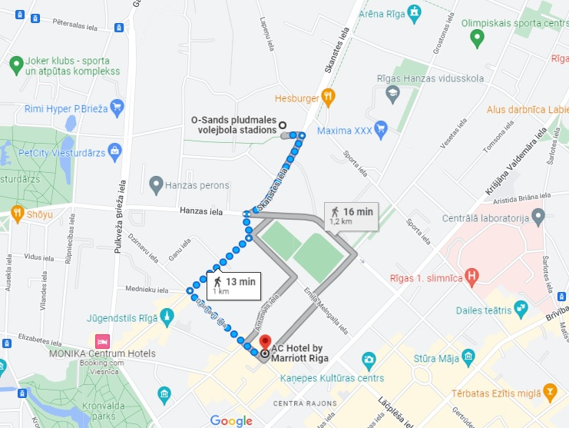
LOCAL TIME ZONE | UTC+2
WEATHER CONDITIONS | Min. Temperature: + 16 С  Max. Temperature:+ 32 С  Sunrise: 06:05  Sunset: 20:47
CURRENCY | EUR
TOURIST INFORMATION | https://www.liveriga.com/lv

